Name:  Teacher: | ___________________________________________  ___________________________ |  | Date:___________
 | Year 9 Mathematics  SCORE:  /20  Topic – Similarity and Scale factor  Working out MUST BE SHOWN for full marks
Total Time: | 35 minutes
Weighting: | 6 %
Equipment: | To be provided by the student:  Pens and Pencils, scientific calculator, ruler and an A4 page of notes.

Q1) Name the two similar triangles in the diagram below. [1 mark]
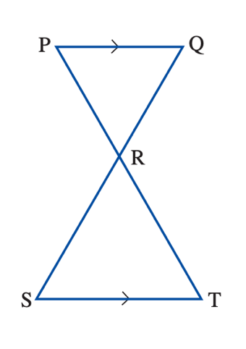

Q2) Find the value of the pronumerals in the diagrams below. [2,1 = 3 marks]
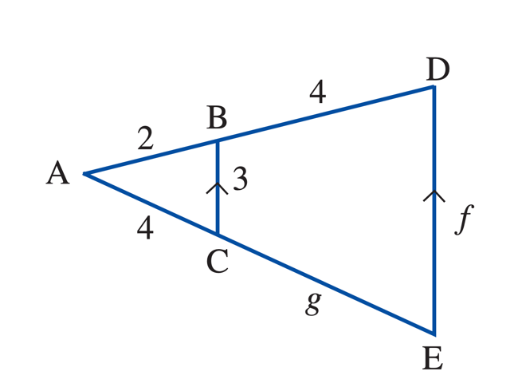
a.

b.
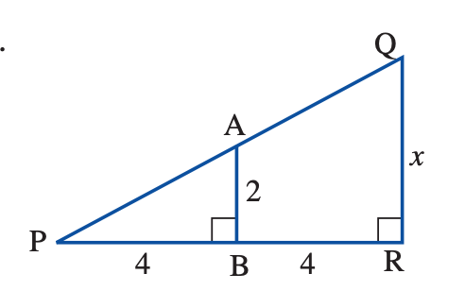

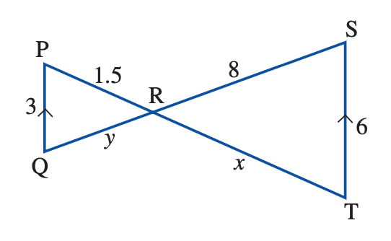
Q3) Find the scale factor from PQR to RST, and hence, find the value of the pronumerals. [3 marks]

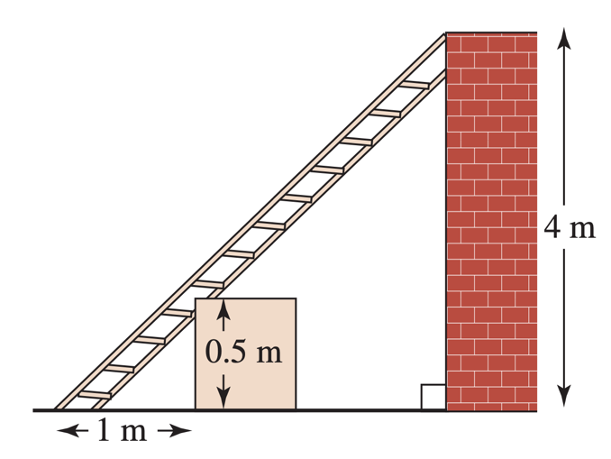
Q4) A ladder leans against a wall, and is supported by a box. If the distance from the base of the ladder to the box is 1m, find the distance from the box to the wall. [3 Marks]

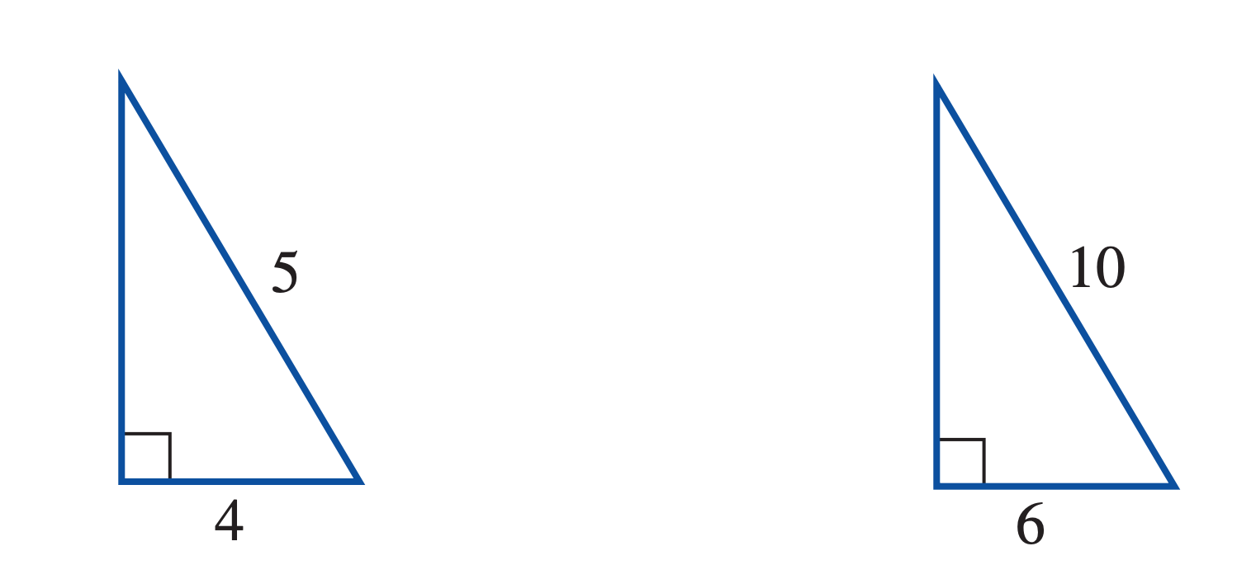
Q5) Justify whether these triangles are similar? [3 marks]

Q6) Travis builds model robots. The kit he uses has a scale of 1:1000 [1, 2 = 3 Marks]
- What does this scale represent?
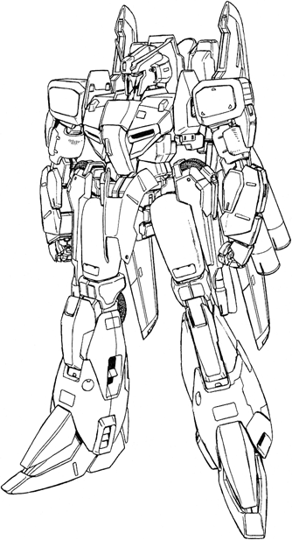

- If the model he builds is 22cm tall, how big would the life size model be in metres?

Q7) Ziva plays tennis at night under floodlights. When she stands 4.5 m from the base of a floodlight, she casts shadow 1.4 m long. If Ziva is 1.7 m tall, how high is the floodlight? [4 marks]

